research coordinator positions
  - Dept of Psychological Sciences, UConn

Description
We are seeking two full-time research assistants (Research Assistant I) to manage research projects at brainLENS (Laboratory for Learning Engineering and Neural Systems; PI: Fumiko Hoeft MD PhD) and NIDL (Neurobiology of Individual Differences in Language; PI: Roeland Hancock PhD) at the University of Connecticut (UConn) on the main campus (Storrs, CT). The assistants will manage and execute a large-scale, multi-site, federally-funded 5-year research projects aimed at investigating the neurobiological mechanisms underlying: (1) language, literacy and cognition in generally healthy young adults using multimodal neuroimaging techniques such as MRI, MRS and TMS (“Compensation Modulation RA”; PI: Hoeft); or (2) intergenerational transmission of language, literacy and math in parent-offspring dyads using MRI techniques (“Intergenerational RA”; PIs: Hoeft/Hancock). Assistants will work closely with collaborators at UConn, University of California San Francisco (UCSF), and Georgia State University (GSU). In addition, the successful candidates will have the opportunity to be involved in other federally and non-federally funded-research projects in the laboratory, gain experience in grant and manuscript writing and large-scale project management, outreach and community engagement projects, and access to a wealth of archival developmental and longitudinal neuroimaging data on language and literacy. This is an excellent opportunity for those interested in research and considering graduate school.

Responsibilities
Project management includes hiring and training of personnel, participant recruitment, data collection and analysis, and purchasing and expense tracking. Other responsibilities include managing and submitting Institutional Review Board (IRB), administrative coordination, and occasional participation in outreach programs. Incumbents will be trained in transcranial magnetic stimulation (TMS), neuropsychological assessment administration, and will assist in magnetic resonance imaging (MRI). Coordinators will have the opportunity to gain skills in grant and manuscript writing, programming, and undertake independent research endeavors.

Required Qualifications
- BA/BS in Psychology, Cognitive Science, Neuroscience, Computer Science or related field
- Experience in research (e.g., conducting research projects)
- Ability to work independently and in a team environment
- Strong time management skills and ability to organize priorities among multiple tasks
- Strong verbal and written communication skills
- Attention to detail and high level of self-motivation
- Basic computer skills (Microsoft Office)

Preferred Qualifications
- Programming skills (e.g., python, matlab, e-prime)
- Experience in data analysis
- Previous neuroimaging collection and analysis experience
- Experience with Qualtrics and/or Redcap
- Flexibility with work hours
- Experience working with kids (preferred in a research setting)

Interested candidates should email brainLENS@uconn.edu with the subject heading “[RA Job (Full Name)]”. In the email they should include (a) a current CV, (b) a one-page cover letter describing qualifications, interest, career goals and which RA position they are interested in (refer to as *“Compensation Modulation” *or *“Intergenerational Project”)*, and (c) a list of 3 potential referees with their contact information.

The preferred start date for the two positions is early June.

LaboratorY
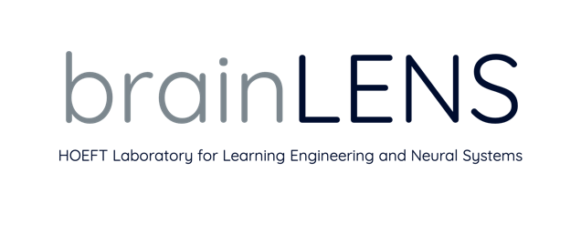
With offices at both University of Connecticut and University of California, San Francisco, we combine cutting-edge, cross-disciplinary research methods with a deep passion for maximizing children’s potential and academic achievement. Dr. Fumiko Hoeft is Professor of Psychological Sciences, Psychiatry, Mathematics and Neuroscience, Director of BrainLENS at UConn and UCSF, and the Director of the Brain Imaging Research Center (BIRC) at UConn. She is a psychiatrist and developmental cognitive neuroscientist, and trained at institutions including, Keio Univ (Tokyo), Harvard, Caltech and Stanford.

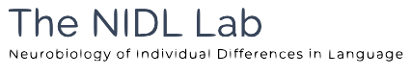
Dr. Roeland Hancock is the Director of the NIDL Lab and Associate Director of the Brain Imaging Research Center at the University of Connecticut. His current research interests include the use of magnetic resonance spectroscopy to study neural excitability in auditory and language processing; distinguishing genetic and environmental contributions to language pathways; and developing tablet-based games for cognitive and literacy assessment. He has a Ph.D. in cognitive science from the University of Arizona, B.S. in mathematics, and was a postdoctoral researcher at the University of California, San Francisco Department of Psychiatry and Weill Institute for Neurosciences.

The University of Connecticut is committed to building and supporting a multicultural and diverse community of students, faculty and staff. The diversity of students, faculty and staff continues to increase, as does the number of honors students, valedictorians and salutatorians who consistently make UConn their top choice. More than 100 research centers and institutes serve the University’s teaching, research, diversity, and outreach missions, leading to UConn’s ranking as one of the nation’s top research universities. UConn’s faculty and staff are the critical link to fostering and expanding our vibrant, multicultural and diverse University community. As an Affirmative Action/Equal Employment Opportunity employer, UConn encourages applications from women, veterans, people with disabilities and members of traditionally underrepresented populations.

